Etsy Multiple Accounts Guide: Etsy Multi-Account Rules & Account Management Tips
More and more eCommerce sellers are adopting the Etsy multi-account strategy — separating different product categories, managing different regional markets independently, and running main stores alongside testing stores. However, as Etsy’s risk control system continues to evolve, learning how to safely manage multiple Etsy accounts within platform rules has become essential for long-term stable operations.

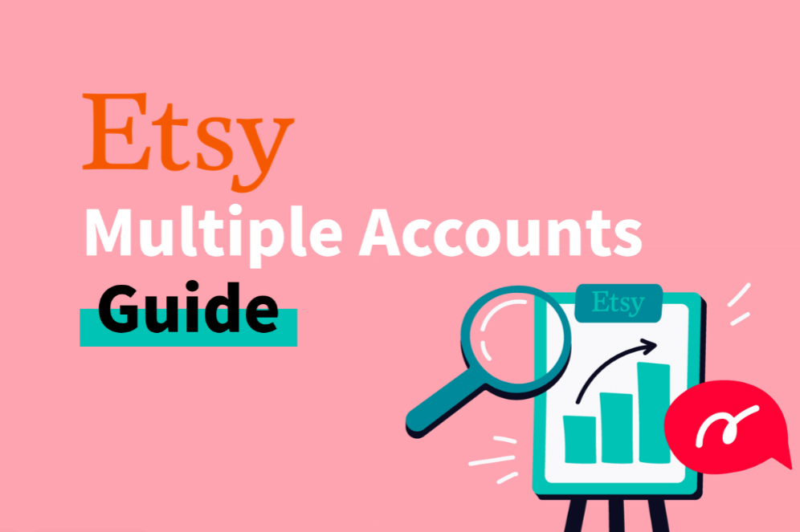

I. Why Do Sellers Use Multiple Etsy Accounts?
As competition on Etsy increases, the growth ceiling of a single store becomes more obvious. Etsy’s algorithm also tends to favor stores with clear niche positioning and strong category consistency. Under this trend, multi-account operations are no longer just an advanced strategy — for many sellers, they have become a standard operational model.
The core idea is simple: separate different business lines into independent stores so each shop can build clearer algorithmic relevance and stronger ranking signals.
● Category separation: Handmade jewelry and digital print products target completely different audiences. Mixing them in one store can dilute category relevance, while separate stores often improve conversion rates.
● Risk diversification: If one store receives poor reviews or gets suspended, all revenue from a single-store business may stop immediately. Multiple stores help distribute operational risk.
● Brand differentiation: A bohemian-style brand for the US and EU market and a minimalist brand for the Japan and Korea market require completely different branding strategies. Independent stores help target each audience more accurately.
● Product testing: Sellers can test new product categories with separate accounts. Successful niches can then be scaled without affecting the data performance of the main store.

II. Does Etsy Allow Multiple Accounts in 2026?
Before discussing Etsy multi-account management, it is important to understand Etsy’s official policy. Etsy does not completely prohibit one seller from owning multiple shops, but it does place strict limitations on how those accounts are used.
Situation | Etsy Policy
Operating multiple independent brand stores for different categories | Allowed
Running separate stores for different regional markets | Allowed
Running a main store alongside testing stores | Allowed (content differentiation required)
Using new accounts to bypass suspended account penalties | Strictly prohibited
Relisting previously removed products on new accounts | Strictly prohibited
Using multiple accounts for fake orders or review manipulation | Strictly prohibited
Using multiple accounts to bypass selling limitations | Strictly prohibited
The key principle is this: Etsy is not focused on whether one person owns multiple accounts. Instead, the platform focuses on whether multiple accounts are being used to manipulate platform rules or evade penalties.
As long as your multi-store strategy serves legitimate business purposes and every store follows Etsy policies independently, your operation remains within a compliant range.


III. How Does Etsy Detect Multiple Account Associations?
Understanding Etsy’s detection system is the foundation of safe multi-account operations. Etsy’s risk control mechanism does not rely only on IP addresses. Instead, it uses a multi-layered account association system.

1.IP Address Association
This is the most direct and basic detection method. If multiple Etsy accounts frequently log in from the same IP address, Etsy’s system may flag them as highly suspicious — especially when accounts switch repeatedly under the same IP within a short time.

2.Device Fingerprint Detection
This is one of the most overlooked risk factors and one of the main reasons sellers get linked even after changing IPs.
A device fingerprint is a collection of identifiable browser and system information exposed to websites, including browser type, browser version, operating system, device configuration, and other parameters.
Even with different IPs, if multiple accounts operate under nearly identical browser fingerprints, Etsy may still recognize them as belonging to the same operator.

3.Payment & Financial Information
Using the same bank card, PayPal account, or payout account across multiple stores is considered a strong association signal by Etsy. Financial data overlap is one of the hardest risk factors to hide.

4.Store Content Similarity
If multiple stores use the same product images, highly similar descriptions, or nearly identical tag structures, Etsy’s content comparison system may identify them as originating from the same source — even without technical association signals.

5.Behavioral Pattern Analysis
Login schedules, operational habits, and even customer service writing styles can become auxiliary risk indicators when combined with other suspicious signals.

6.Cookies & Local Storage
Switching between multiple Etsy accounts in the same browser without fully clearing session data may directly expose account relationships through residual cookies and local storage data. This is one of the most common operational mistakes.

IV. How to Safely Create and Manage Multiple Etsy Accounts
The core of Etsy multi-account risk management is not simply using anti-ban tools. It is about building a complete isolation system.
The most important principle is that accounts, network environments, and browser fingerprints must work together as fully independent entities. If any layer becomes associated, Etsy may detect connections through behavioral or environmental signals.

1.Account-Level Isolation
Each Etsy account should use a separate email address, independent phone number, and separate bank card or PayPal sub-account from the beginning.

2.Device Environment Isolation
Environment isolation is one of the most important anti-association strategies for Etsy multiple accounts. The goal is to make every account appear as a completely independent real user.
Common approaches include:
● Device isolation: Run different accounts on separate computers or virtual machines with independent network environments.
● Anti-detect browser isolation: Use an Anti-detect browser to generate unique browser fingerprints for each account, combined with a dedicated static residential proxy for network isolation.
A common setup standard for larger eCommerce teams is:
One account = one Anti-detect browser profile + one dedicated static residential proxy
This creates simultaneous isolation at both the device and network levels.

3.Network Environment Isolation
This is the most critical technical part of Etsy multi-account management.
After preparing isolated devices or browser environments, sellers also need proper proxy-based network isolation. Free proxies usually rely on data center IPs that have already been heavily flagged by platforms, making them much more likely to trigger risk controls.
A more stable approach is using a dedicated static residential proxy that behaves like a real residential network environment.
In practice, sellers can obtain target-country IP resources from IPFoxy Proxies and assign one dedicated static residential proxy to each Etsy account. This helps improve network authenticity and exclusivity while reducing association risks between accounts.

4.Content Differentiation
Each store should use original product images, independent descriptions, titles, and tags. Avoid copying content between accounts. Store visual styles and customer service communication should also remain clearly differentiated.

5.New Account Warm-Up
Do not upload products aggressively immediately after registration.
During the first week, focus on completing store information and basic setup. Starting from the second week, upload products gradually (around 5–10 SKUs initially), then slowly increase activity over time so account growth appears natural and avoids triggering abnormal behavior detection.

V. FAQ

Q1: What happens if Etsy detects account associations?
Minor cases may result in limited account functions, while serious cases can lead to permanent suspension of all related accounts. Appeal success rates are generally low, so prevention is far more important than recovery.

Q2: What is the most common mistake in Etsy multi-account operations?
Many sellers only change the IP but forget to isolate browser fingerprints, or they bind multiple stores to the same bank card. Either mistake may result in full account association.

Q3: Can you reopen a store after suspension?
You would need to replace all associated elements completely, including devices, IPs, emails, and payment methods. Reusing any previously linked information may trigger another suspension, so the risk remains high.

VI. Conclusion
The core of safely operating multiple Etsy accounts is complete isolation: network environments, device fingerprints, payment information, and content assets all need to remain independent.
Treat account isolation as a standardized operational process from the very beginning rather than trying to fix issues after problems occur. That is the real foundation for turning a multi-store strategy into sustainable business growth.

